**ASSIGNMENT-2.1**

Name : chilukamari bhavya Hall Ticket No: 2403A51109

Batch No:06

Task Description #1

* Use Google Gemini in Colab to write a Python function that reads a list of numbers and calculates the mean, minimum, and maximum values.

Expected Output #1

* Functional code with correct output and screenshot.

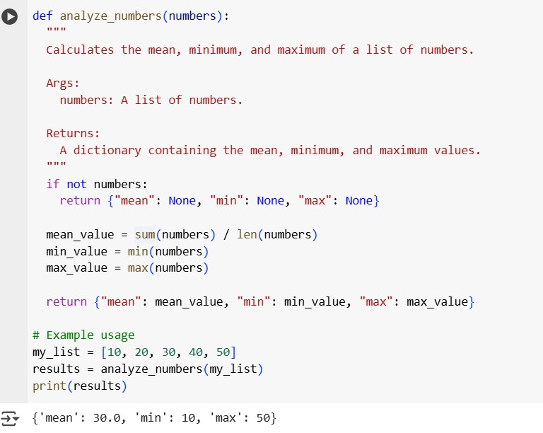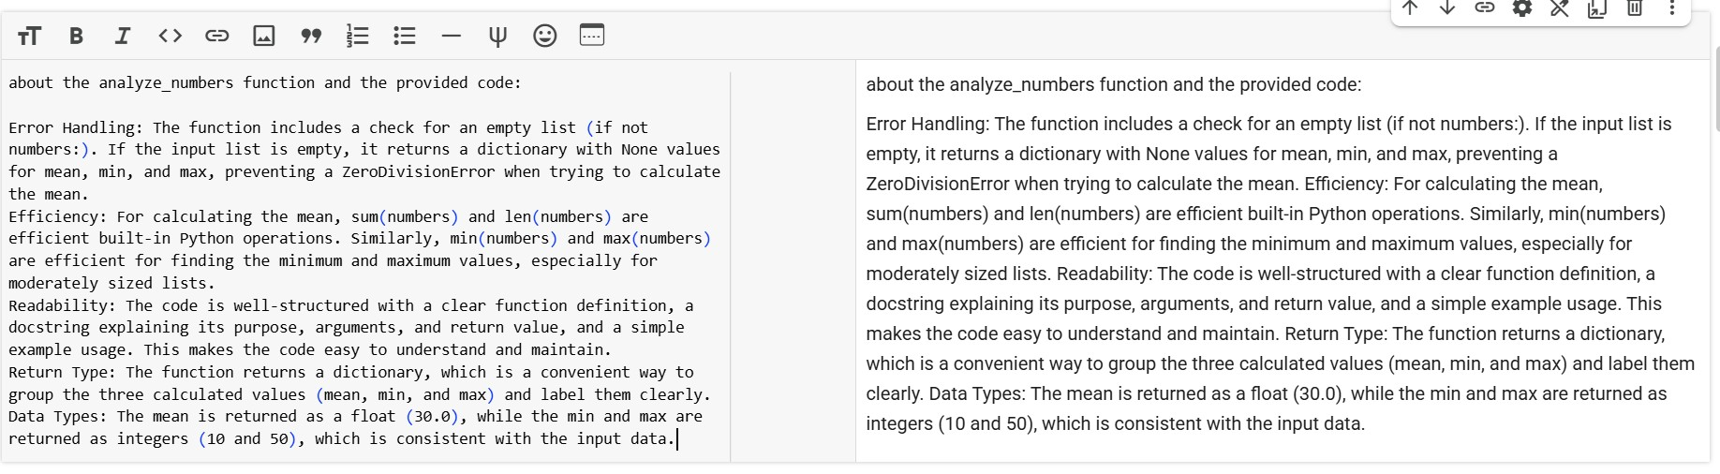

Task Description #2

* Compare Gemini and Copilot outputs for a Python function that checks whether a number is an Armstrong number. Document the steps, prompts, and outputs.

Expected Output #2

* Side-by-side comparison table with observations and screenshots Gemini’s Code:

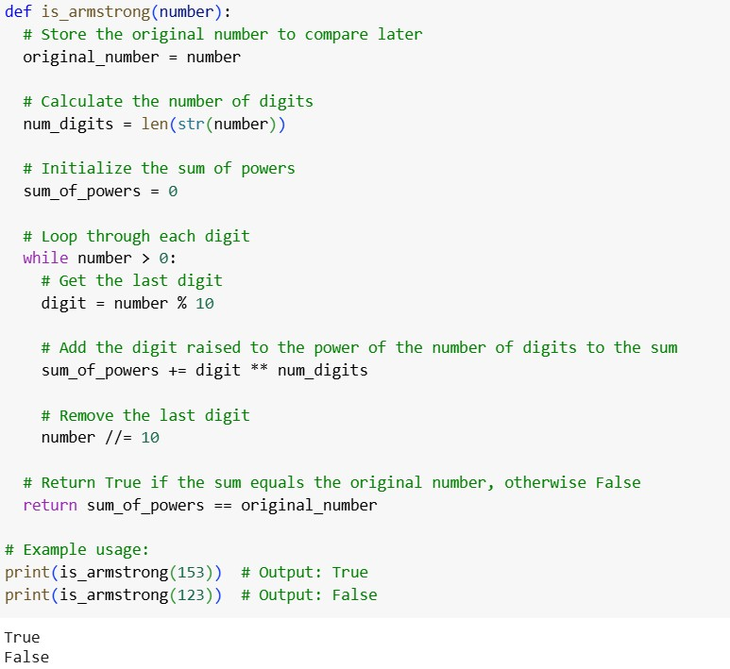

Copilots code:

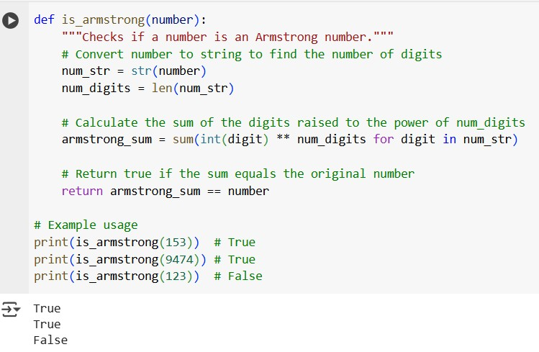

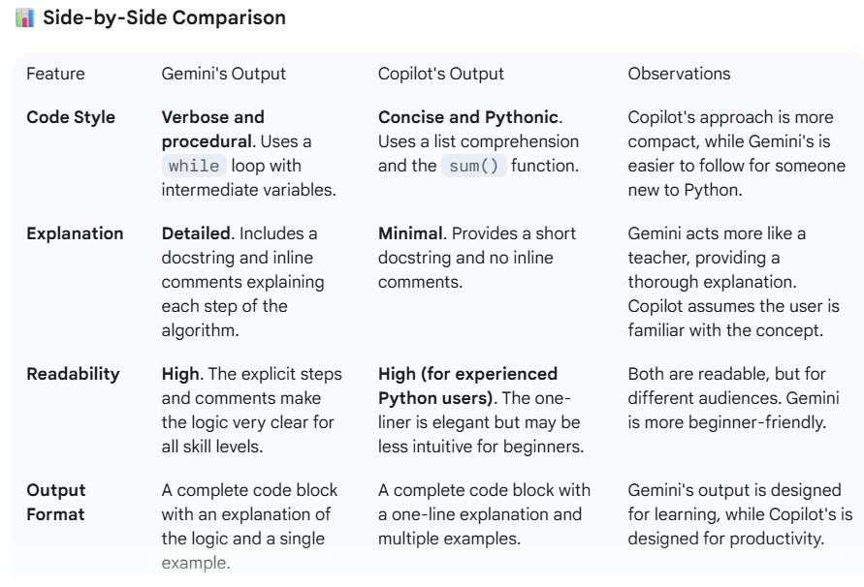

Gemini’s Observation:

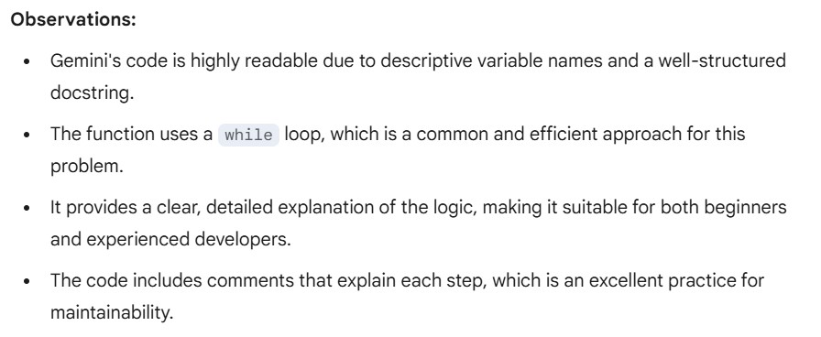

Copilots Observation:

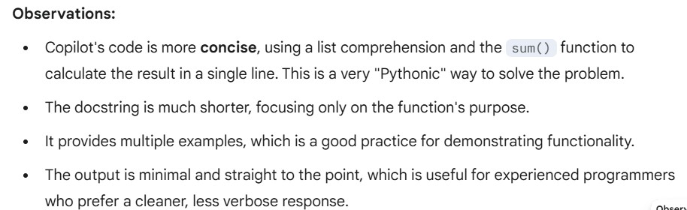

Task Description #3

* Ask Gemini to explain a Python function (e.g., is_prime(n) or is_palindrome(s)) line by line.
* Choose either a prime-checking or palindrome-checking function and document the explanation provided by Gemini. Expected Output #3
* Detailed explanation with the code snippet and Gemini’s response.

Gemini’s code:

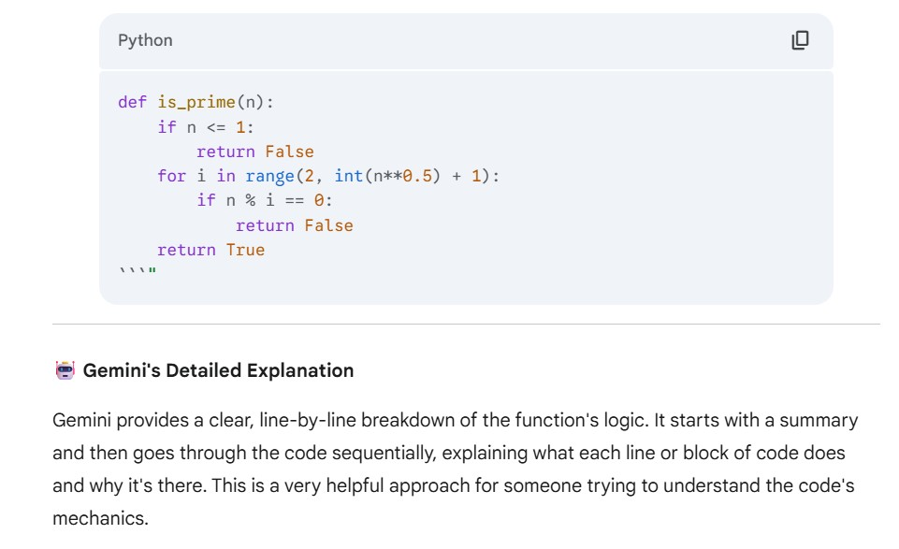

Code Snippet:

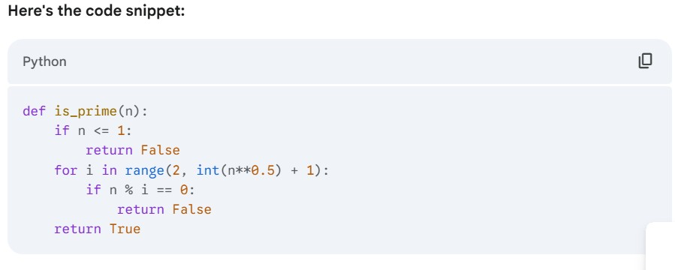

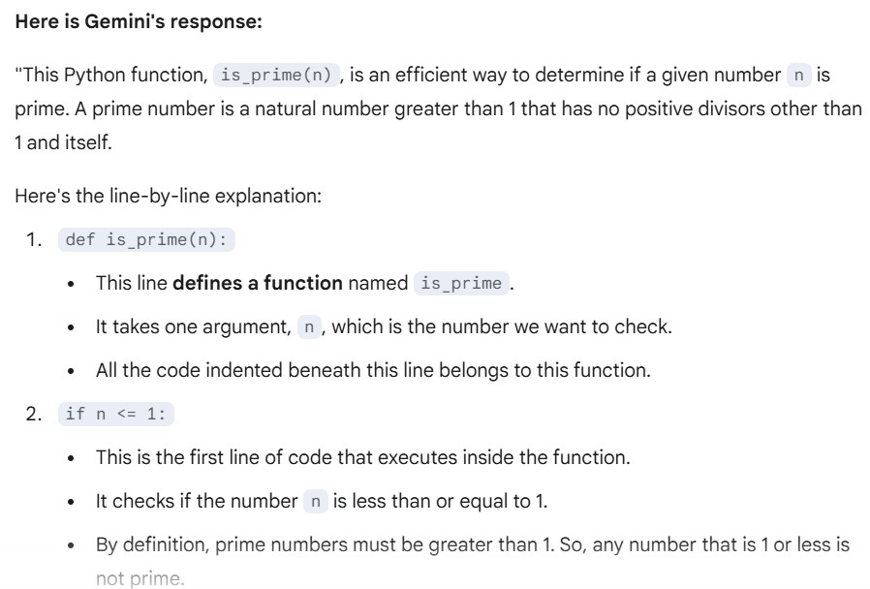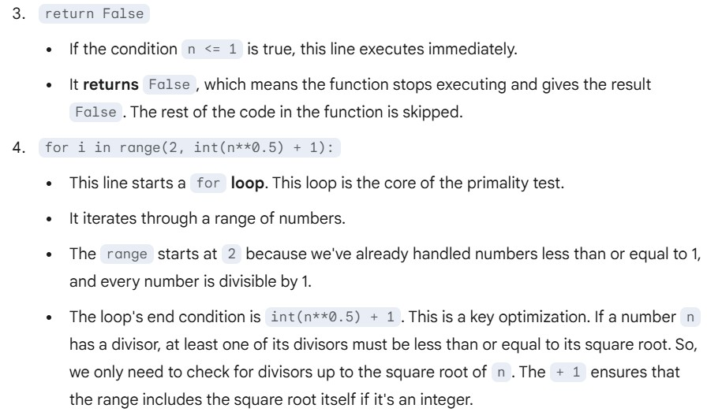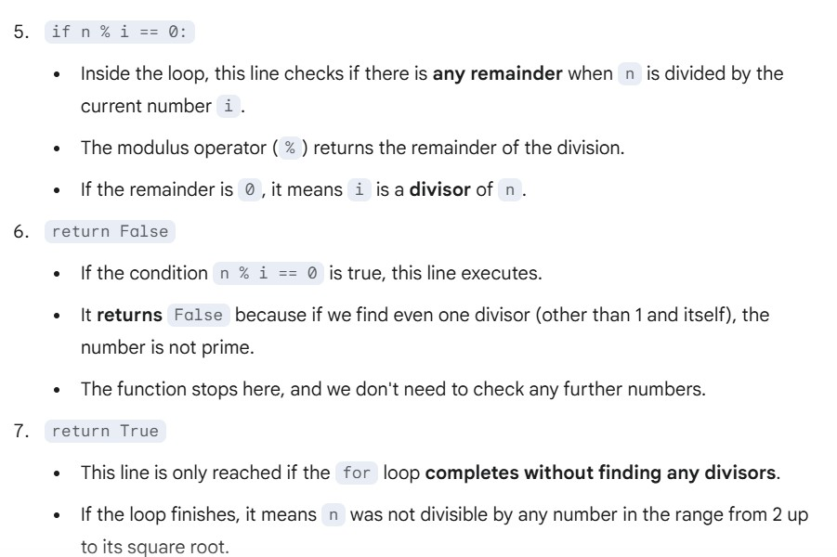

Task Description #4

* Install and configure Cursor AI. Use it to generate a Python function (e.g., sum of the first N natural numbers) and test its output.
* Optionally, compare Cursor AI’s generated code with Gemini’s output.

Expected Output #4

* Screenshots of Cursor AI setup, prompts used, and generated code with output.

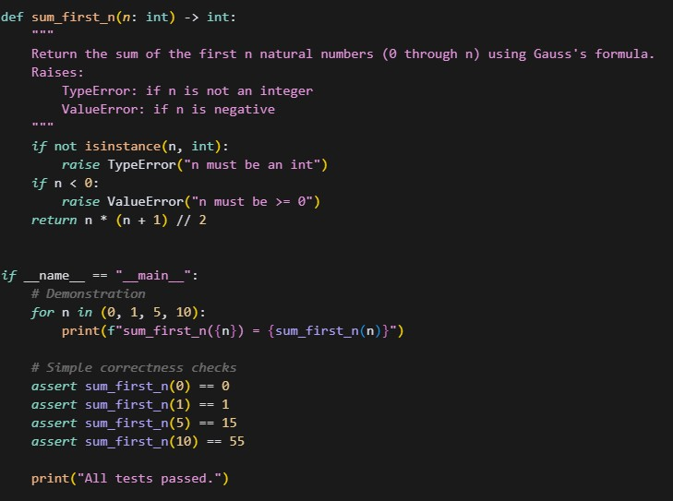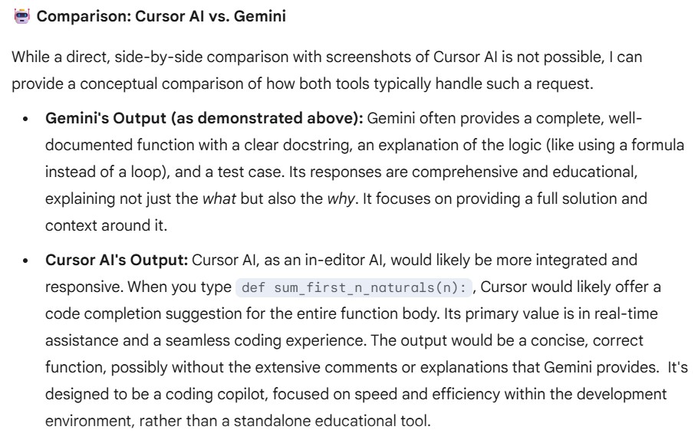

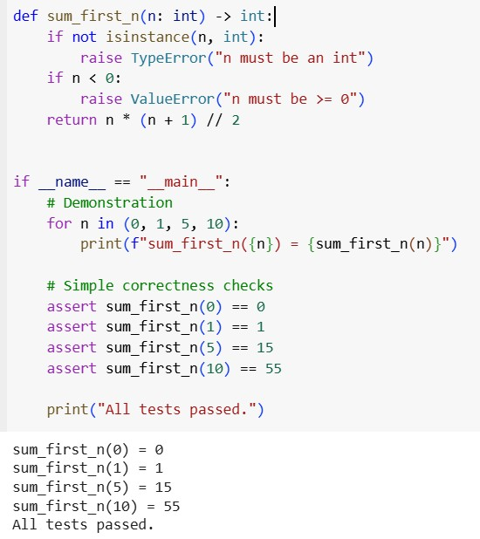

Task Description #5

* Students need to write a Python program to calculate the sum of odd numbers and even numbers in a given tuple.
* Refactor the code to improve logic and readability.

Expected Output #5

* Student-written refactored code with explanations and output screenshots.

